DATA SHEET :

Name of the Product : Methyl Sulfonyl Methane USP
Chemical Name : Dimethyl sulfone
Molecular Formula : C₂H₆O₂S
Molecular Weight : 94.13
CAS No. : 67-71-0
Structure :

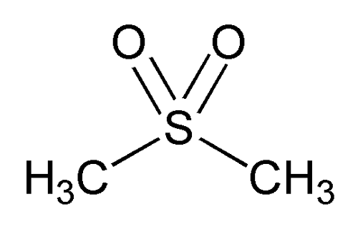

Methyl Sulfonyl Methane (MSM) is a naturally occurring organic compound. Recent interest in sulphur has been stimulated by its use in the form of Methyl Sulfonyl Methane on human beings. Sulphur is important in the formation of Collagen and Glucosamine that are necessary for the maintenance of healthy bones, Joints, ligaments and tendons. A direct relationship between the amount of MSM present in the body and resistance to allergies has been established. MSM is essential for the production of keratin, collagen, and important constituents of hair, skin and nails. MSM is also useful in producing the insulin in the body which makes cells more permeable thereby allowing them to absorb blood sugar.

SPECIFICATION :

Name of the Product : Methy Sulfonyl Methane USP
Reference : USP-35

S.No. | Test | Specification
1. | Appearance | White Powder or flake crystal.
2. | Identification:
 | a) IR identification | The IR spectrum of the sample should be concordant with the IR spectrum of the MSM working standard.
 | b) Retention time | The Retention time of the sample assay peak corresponds to the Standard peak.
3 | Physico- Chemical Analysis:
 | a)Solubility | Freely Soluble in water, in methanol, in alcohol and in acetone. Sparingly soluble in ether.
 | b)Water content (%, w/w) | NMT 0.1
 | c)Melting point (⁰C) | 108.5 – 110.5
 | d)Particle size | 100 % Passing through 40/60/80 mesh.
4. | Heavy metals (ppm) | NMT 3
5. | Assay (% w/w) | 98 to 102
6. | Chromatographic purity (%) | NLT 99.8
 | a). Limit of Dimethyl Sulfoxide as an individual impurity (%) | NMT 0.1
 | b). Any other individual impurity (%) | NMT 0.05
 | c). Total impurities (%) | NMT 0.2
7. | Microbiological Report:
 | a) Total Microbial Count ( Cfu/g) | NMT 1000
 | b) Yeast & Mould (Cfu/g) | NMT 100
 | c) E- Col/ 10 g | Should be absent

